**MZUMBE UNIVERSITY**



**FACULTY OF SCIENCE AND TECHNOLOGY**

**PROGRAM: DIT 1**

**COURSE CODE: CSS 062**

**COURSE NAME: MAINTAINING COMPUTER SYSTEMS**

**LECTURER NAME: Mr. KURIHO**

**TASK: GROUP ASSIGNMENT**

**SUBMISSION DATE: April 21, 2024**

**GROUP NO.9**

|  |  |
| --- | --- |
| **MEMBER’S NAME** | **REGISTRATION NUMBER** |
| **IAN ULOMI** | **14233056/T.23** |
| **SAMWEL NATHANIEL** | **14233060/T.23** |
| **TUMAINI ANDERSON** | **14233054/T.23** |
| **NAJMA DUTCH** | **14233051 /T.23** |
| **RAHELI KITUTU** | **14233045/T.23** |
| **JOSHUA KABANGA** | **14233044/T.23** |

1. Device specification

* Device name; LENOVO QUADRO 1200
* Processor; 2.0
* RAM; 8GB
* Connectivity; USB ports, Ethernet port, headphone jack, HDMI, Bluetooth and WIFI reader card.
* Graphics; 4GB, GDDR5.
* Display; 1920 x1080 resolution

2.Problem identification

As a group, we observed the signs shown by the computer to identify the problems within it. These signs were as follows.

* The computer was lagging.
* The computer couldn’t open other files
* The computer was stacking
* The computer took a very long time to boot

After keen observation of the signs shown by the computer, we discovered the main problem with the computer was the window operating system.

3.Solutions applied to the problem.

Since the problem of the computer was the window operating system. the best solution was to install a new window to the computer.

# Installation of operating system

Operating system is the group of computer program that coordinates all activities among the computer hardware devices. This manages the computer hardware and software resources and provides common services for computer programs.

Functions of operating system are:

* Provide user interface
* Control hardware access
* Manage files and folders
* Manage application

But before you install the new operating system you should

* Backup all the data
* Tell the client data loss may occur
* Make sure your data transferred successfully

The following are the procedure of installing windows 7

**Step 1:** Turn on your computer and press F2 continuously. Go to boot option and select USB driver option, and the window will start loading its files.

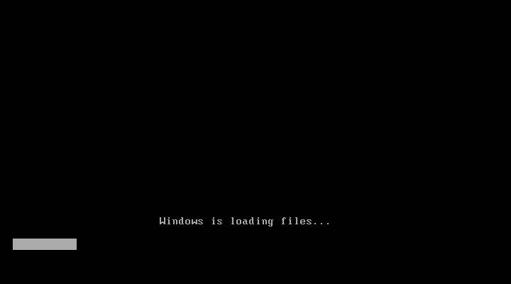

# *Picture 1. Turn on your computer*

**Step 2:** Now you will get the Windows setup windows. Select English language and click next, click ‘Install Now’ button and proceed with the next step.

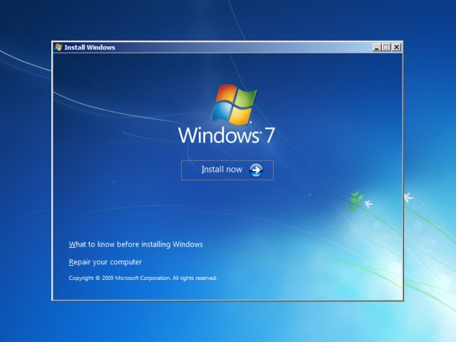

# *Picture 2. Windows install*

Step 3: License agreement page appear, Check ‘I ACCEPT’ to accept license agreement and click next. Then the option for window installation will appear either ‘UPGRADE’ or ‘CUSTOM’ installation. For Clean version installation click CUSTOM.

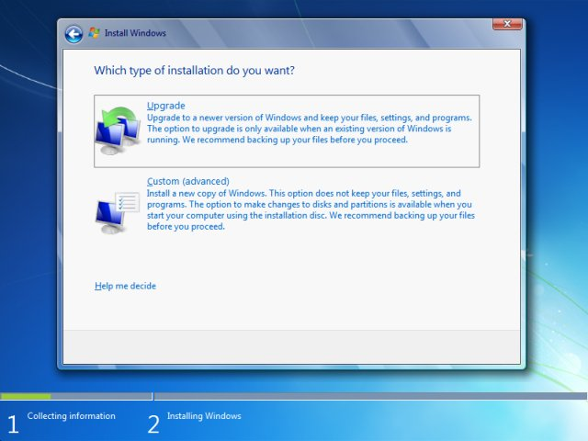

# *Picture 3. License agreement page appear*

**Step 4:** The next step is to make partition of your drive. This is most important part of the installation. Make allocation of the drive. If you want a new drive, simply click on drive, then click ‘New’. A new drive will be created.

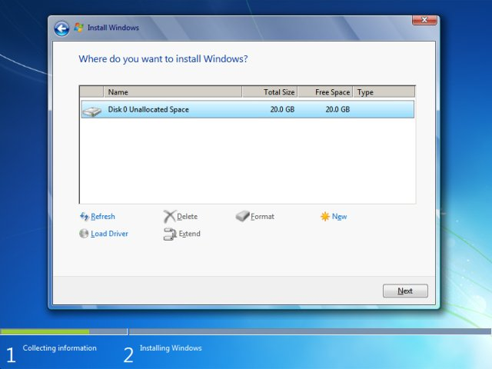

# *Picture 4. Partition of drive*

**Step 5:** After create, select the drive you want to install the window. Click ’format’ if you want to erase all the data contained in the drive or click next to proceed the installation of window.

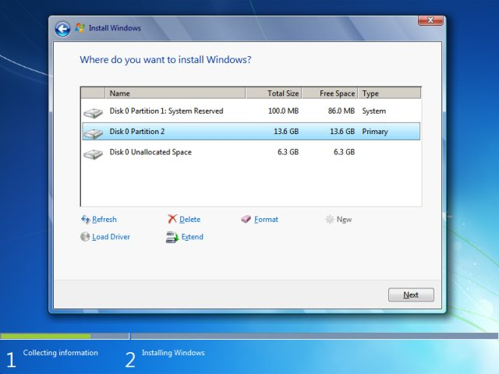

# *Picture 5. Drive to install window*

**Step 6:** Window will start installing its files, in this step don’t plug in or off your device, because you may cause interruption and the data might lost

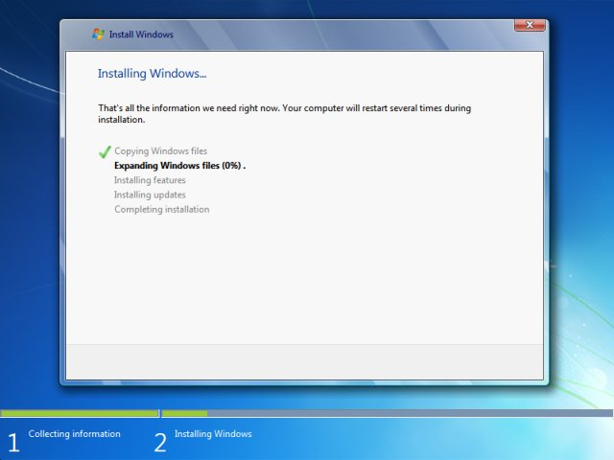

# *Picture 6. Window start installing*

**Step 7:** After all files installed. The computer will be booted and will see the ‘User Settings’ Screen. Add your Name and password and proceed to ‘NEXT’.

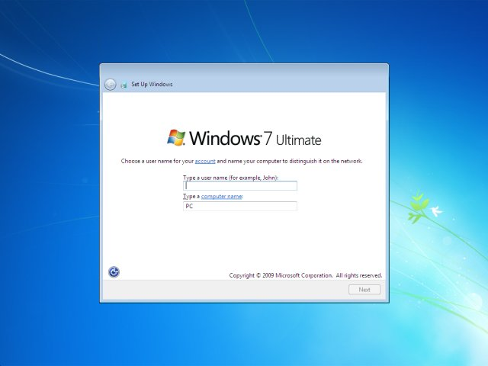

# *Picture 7. User settings name and password*

**Step 8:** This step activates your window. Check at the back of your windows CD/DVD cover there will be a PRODUCT KEY. Add the key and click ‘NEXT’

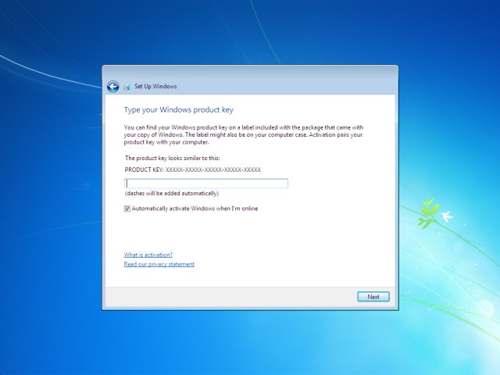

# *Picture 8. Add product key*

Step 9: Now you installed your window.

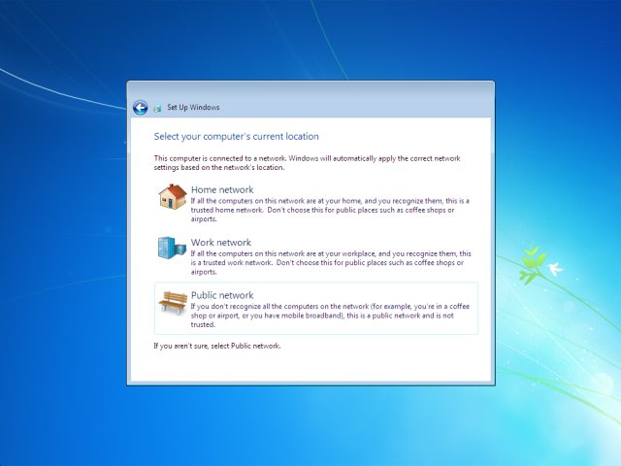

# *Picture 9. Installation complete*

Last step-Congratulation: you have installed your windows. Now you can see your Desktop.

Now you can use by setting your Desktop.

4.Tools used

Due to the problems found in the computer we were dealing with, the following tools had to be used. This was to simplify the whole process of computer maintenance.

* USB flash driver; This is a small, portable device that plugs into the USB port on your computer. USB drives are commonly used for storage, data backup, and transferring files between devices. We used this tool to transfer files to the computer.

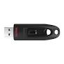

1. CONCLUSION

After the completion of the whole process of window installation, the computer didn’t show any signs that it had before. Meaning the problem was resolved. We had to install the Microsoft word since the computer didn’t have .And lastly we updated the antivirus for security purpose.